Miller <redacted>
Forest Stewardship Plan

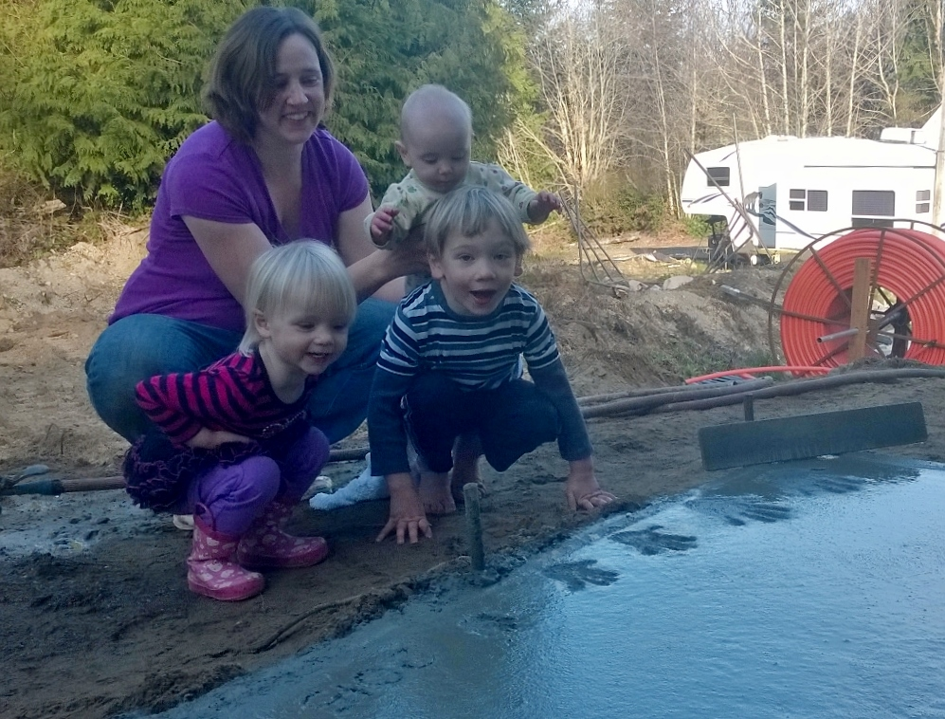

Forest name: | Miller <redacted for PII> Woods
# of acres plan coverd: | 20 acres
Forest certification number:
Plan prepared by: | Land Owners
Date plan prepared: | 3/4/2015
County and state: | Kitsap, Washington

Plan revision dates
Plan revised | Monitoring data incorporated

- Legal description
<redacted>, recorded under auditor's file nos: <redacted legal lot description>

- Stewardship Vision: To provide for the health of the forest (including the wildlife that may use it), and inasmuch as activities of an aesthetic nature are compatible with a healthy forest, to provide for our enjoyment of the property, visually and recreationally. Ideally, the forest management plan will provide guidance not only during our ownership of the property (fifty years, give or take), but also to those who may own the property in the future. Short and long term goals and objectives:
  - Short term goals
- Remove black berry patches, nettle patches, and thin alder trees replacing both with Douglas fir purchased in lots 100 – 1000 from WA DNR, native ferns, salal and other native ground cover plants. http://www.dnr.wa.gov/RecreationEducation/News/Pages/nr09_066.aspx
- Fortify and expand current road and trail system on the property allowing for enhanced recreational use of the property, and better access to areas being worked.
- Provide for the health of the forest, to ensure that it survives our ownership, including improving fire safety
- Grind or chip slash left from thinning, to provide for covering trails
- Establish a small herd of goats to help deal with sticker bushes and other nuisance plants
  - Long term
- Develop pond and wetland systems for wildlife habitat, irrigation, and mosquito control
- Manage forest resources for sustainable harvesting

- Map
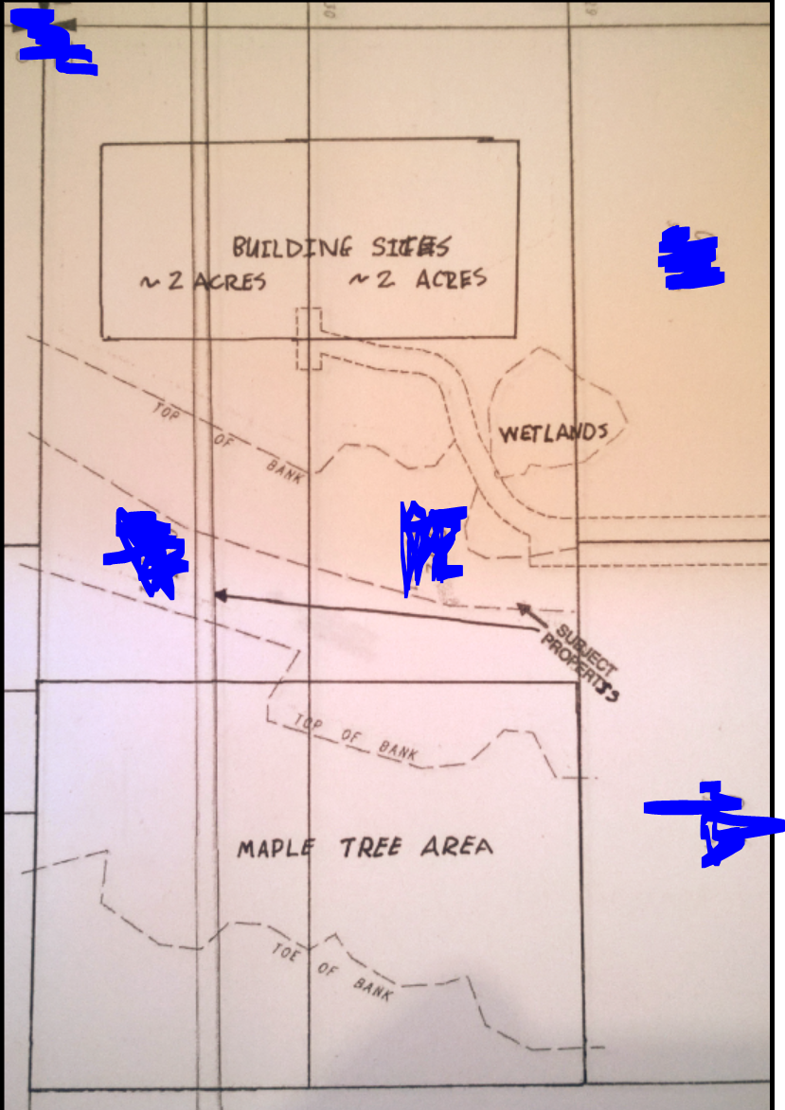
1 Map of land with PII data redacted

- General property description
The property was a 20-acre lot in the early 2000’s then subdivided into two 10 acres lots by the previous owner. The previous owner created a main road through the middle of the first 10 acres to access the rear 10 acres, installed a well, and brought in power under the road.

Based on vegetation and tree growth the property was most likely logged in the 80’s. There are very few trees over the age of the 30 years on the property, most of what is growing are alder trees which have naturally grown since the clearing, and the remains of timber trails are still noticeable on the property.

The lower (east) half of both properties have a significant slope that is dominated by large maple trees creating a leafy canopy hindering the grown of much vegetation on the ground beyond nettles and ferns. The ground is also damp due to lack of light, water runoff and the presence of some small seasonal water flows.

The front (north) 10 acres has an acre plus area pond designated as a wet land on the map. There is water in the pond 10 months out of the year.

We purchased the back property 3 years ago with the vision of building a house and providing room for our growing family to enjoy the property. We purchased the front 10 acres in 2014 when the owner said someone wanted to buy it and put in as many houses as possible. We’d always wanted to purchase the additional 10 acres, the threat of the option leaving sped up our purchase.

Neighboring properties are all over an acre with houses on them and not sub dividable. Except for one 7-acre triangle between the lower half of the bottom property and burley road. We’ve been in communications with the current out of state owner to purchase this land to add to our forest. The 7 acres is very hilly, and cut apart by 2 year-round creeks. It would be a difficult task in geotechnical engineering to build on. We would like to own it to leave it as a forest and have access to the creeks for our children.

- Existing conditions and resources
Soil
The property is made of sandy loam soil to a depth of 5-20 feet depending on location on top of compressed sand hardpan. The USDA survey shows the average rooting depth for this type of soil to be between 20 and 40 inches. Permeability, available water, and wind-throw potential are all medium, with high compaction potential for the soil when wet. Erosion potential for this soil is low, but the high compaction potential suggests that low-impact logging equipment should be used. Either tracked equipment or very low-pressure tires should help avoid damaging the soil. Engaging in any significant logging activities during the dry season should also help.

Recommendations: As noted, restricting logging activities to the dry season, as well as using low -impact logging equipment, should help avoid the risk of soil compaction.

Water Quality, Riparian and Wetland Areas

There are seasonal small riparian areas on the property, and a large acre pond on the front property.

Recommendations: Measures need to be taken during forestry activities to protect areas of these types. Proper buffers and low impact plant replacement will be used to maintain sensitive areas. Work performed near the riparian areas will be done by hand not utilizing any equipment that might harm the soil or sensitive plants in the area.

Forest cover provides for infiltration of water into the groundwater table helping maintain water quality and quantity. Improving the health of the forest and maintaining vegetation boundaries will promote that watershed function.

- Stands
Due to logging in the 80’s followed by no visible replanting efforts there are no established stands of any significate size comprised or marketable or homogeneous trees.

Being said, the lower half of each 10-acre lot could be considered a stand due to the sloping nature and dominate maple tree canopied areas. One of the long term goals will be to slowly remove the maple trees from the lowest part of the property upwards and establish stands of Douglas Fir.

- Stand Silvicultural objectives
Throughout the property the understory is almost entirely common, native species: ferns, mosses, Salmon Berry, Huckleberry, black berry, Sala and other native plants. Along the road, some invasive species are trying to establish themselves, primarily Blackberry which will be dealt with using swift goat power.

No apparent insect infestations or animal damage has been noted, in all areas.

Recommendations: The most urgent need is eradicating the black berry bushes attempting to take hold along the road. Control along the road will be important to provide for fire prevention, as well as to remove the invasive species present there.

Next goal will be thinning out the maple trees on the lower half of the property. This will allow for an increase in light and space between the trees and make room for planting new trees; over time this will create a healthier forest and reduce and alleviate general stress on the larger trees in the forest.

The thinning will encourage decomposition of woody debris, as well as significantly reducing the fire danger within the property. The decomposition will help reduce the fuel available for fire and reduce ladder fuels. The thinning will help provide adequate spacing to keep the trees healthier and more resistant to fire.

Thinning heavily and replacing some of the removed trees with trees from different species, that are generally disease resistant, will help to improve the overall health of the forest,

- Fish and Wildlife Habitat
There are no known threatened or endangered species that require protection on the property. However, a primary goal of forest management will be to provide an appropriate habitat for a variety of wildlife. My father instilled in me a love of the snag, any opportunity to leave a snag, or create one by topping a tree during thinning will be taken.

The property does include wetlands. There are no fish in the wetlands areas but amphibians do take advantage of the water and crocking frogs can be heard approaching the 100db level during evening hours of spring and summer.

Other than a number of stumps and logs left from the original logging of the property, there is little in the way of coarse woody debris.

Recommendations: Logging activities should protect snags as much as possible. Almost all of the trees on the property currently are smaller than what might be an ideal size for a snag. However, there may be a handful of Maple trees large enough to warrant topping and turning into snags. Likewise, while smaller than ideal, any alder that would otherwise be removed as part of a thinning operation, but which isn’t marketable for timber, should be left standing and topped for the creation of a snag, especially where no snag that size or larger already exists in the vicinity. Nesting boxes may be installed around the property, but these will not provide all of the benefits that an actual snag will.

All forestry activities should avoid damage to any of the existing coarse woody debris. Most of this CWD is in the form of very large stumps, which are unlikely to suffer any serious damage. But other CWD, large logs lying on the ground for example, should be avoided by any forestry activity, to avoid collapse or breakage of usable habitat.

In addition to preserving and creating snags, variable density thinning should be used to provide for a wider variety of habitat on the property. Most of the thinning will inherently open up the forest to provide habitat and hunting areas for avian predators (e.g. owls). Heavily thinned patches will provide warmer sites for those animals that require or prefer that, as well as increasing the amount of “edge” on the property. Retaining some of the more densely tree areas will retain that type of habitat, affording some protection from predators, as well as better supporting under-story plants that prefer shade (e.g. ferns, mosses). Generally, variable density thinning will allow the property to support a wider variety of under-story plants, and thus of wildlife that depend on those plants.

Finally, different tree species should be planted where possible. This will help improve the vertical structure by creating a more multi-aged forest, while at the same time providing diversity horizontally

- Recreation/public access
Currently there are no specific recreational resources on the property. However, it is our desire to use the property recreationally, through the development of trails suitable for hiking, and mountain bike riding. There will be no public access to the property.

Recommendations:
Development of trails will happen long before any logging operations. The trails established will be designed for recreation purposes, providing access to most areas, and can be utilized for activities related to logging. Where possible, access for logging activities should be made where recreational trails would be desired
Trails should be surfaced with material found on-site where possible. Forestry activities will result in a large amount of slash, should be chipped or ground into a consistency suitable for covering trails.

In certain high-traffic areas, gravel may be warranted, but otherwise chipped or ground slash should be used. In the unlikely event that insufficient debris is available for the maintenance of low-traffic trails, degradable material such as wood chip will be brought in.

Management Timetable

Year | Area | Management Activity
2013-2015 | House | Residential development and establish our home.
2015 | Road | Remove brush and Black berry vegetation
2015 | All | Establish trail system and clear underbrush and debris where needed
2016-2020 | Lower | Remove Maple trees and establish Douglas fir stands
2015 | Wet lands | Thin the wet lands
2015-2030 | All | Monitor planted seedlings and suppress competing vegetation to provide the healthiest environment for the trees to grow
2030-2040 | All | Evaluate now established stands for thinning opportunities; either perform commercial thin, or fell trees as necessary and use on-site, depending on what is economically feasible
2041 | All | Evaluate commercial thinning / harvesting and replanting as needed
Ongoing | All | Monitor tree health and invasive species across property; take steps if necessary to prevent health problems from spreading
Ongoing | All | Further develop, and maintain trail and recreational areas.

Appendix – Supplemental land images

Side Aerial view from 2013
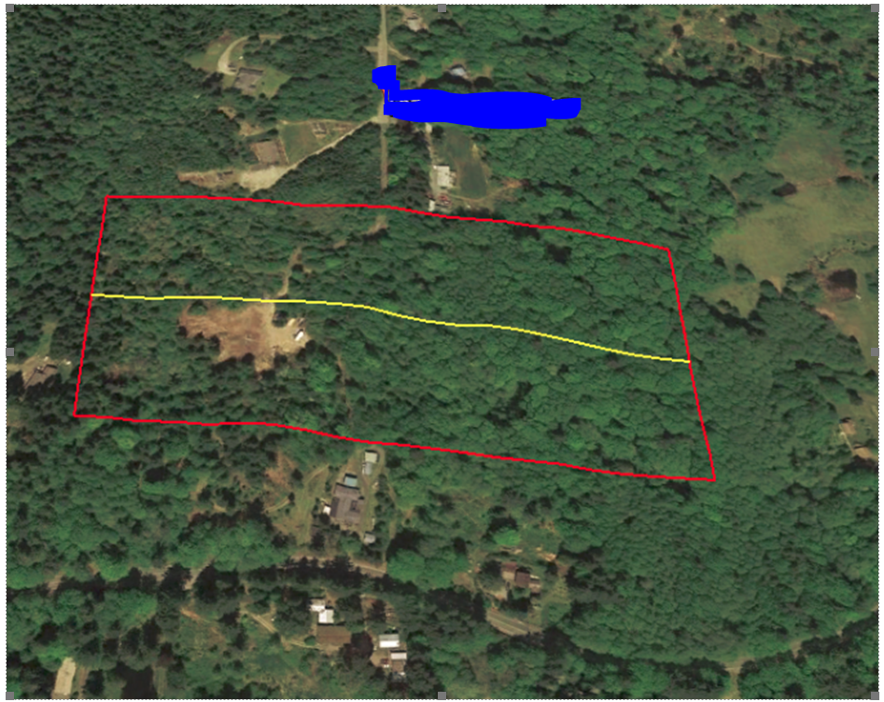

True Aerial view from 2013

In 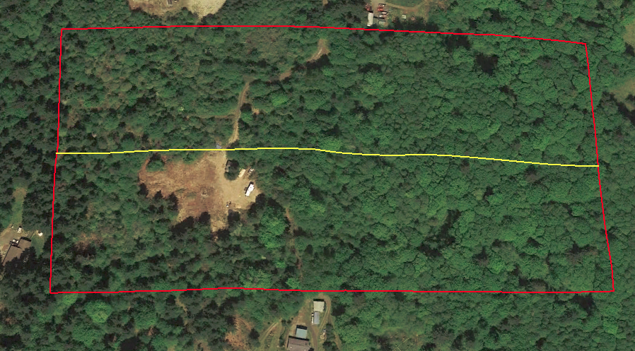

In both aerial views can be seen the cleared homestead area for the main house.

Topographicial map

